Homework 3

Introduction

Implement  a  histogram equalization function that can perform equalization on

8bit gray level image.

Approach

While encourage to use MATLAB my implementation was done with python and OpenCV

A package that is useful for image and data processing. I used an Object Oriented

approach and created a class for Intensity transformations. In the future, I hope to add more

algorithms from homework and projects related to Intensity transformations in the file. I hope

this will pay off in the future when it comes to studying for tests. Currently when the class is called the user

must input an image. The constructor will then call the histogram equalization function and store the

result. After the transformed image is created it is stored in the class object and retrieved using an

accessor method. The functions can be called directly to perform transforms on the image.

The user would need to set the image using the class and call the image using OpenCV.

Automated usage:

path = “my/image/path”

img = cv2.imread(path)

ixf =histogram_equalisor(img)

new_img = ixf.get_img()

Manuel usage:

path = “my/image/path”

img = cv2.imread(path)

x = histogram_equalisor()

x.set_image()

x.hist_eq()

new_img = x.get_img()

Experimental Results

The results of implementing the class were successful but had unexpected consequences. What

surprised me at first the drop in quality but I later realized this was due to the image being

represented as 8bit.

High Contrast

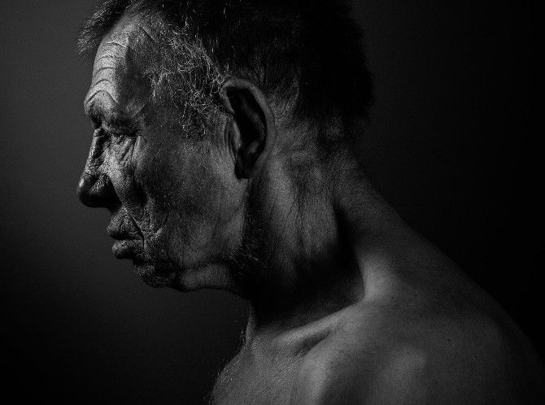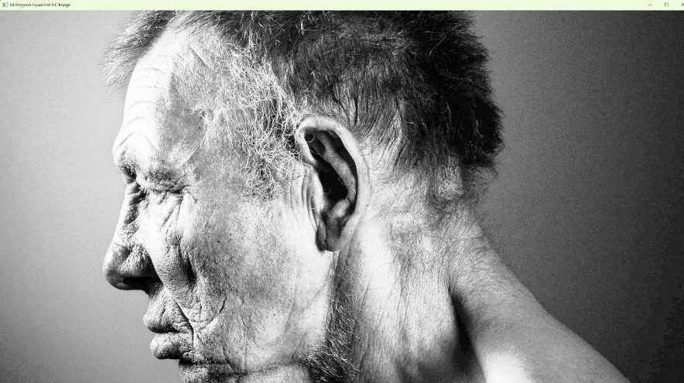

Discussion

For my high-contrast image, the equalizer worked relatively well. I believe this is due to its high pixel

density making the noise introduced less visible. I believe I was able to get a good range of value

with the highest being around 175 however the majority of pixels are relatively dark from observing

the plot.

Low Contrast

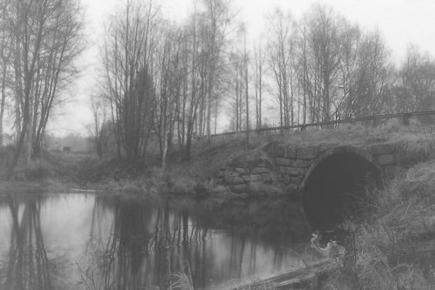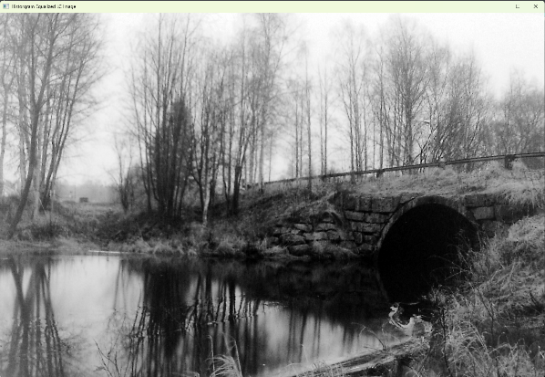

Discussion

For the “low contrast” image the equalizer worked very well and provided an image will a lot of

contrast. I believe this is due to the image having higher contrast than i assumed when first

selecting it. After seeing the original image histogram it is clear that the equalizer was able to do

a good job due to the image already having an of colors and a clean skew that was smothered

and redistributed more evenly.

Light Contrast

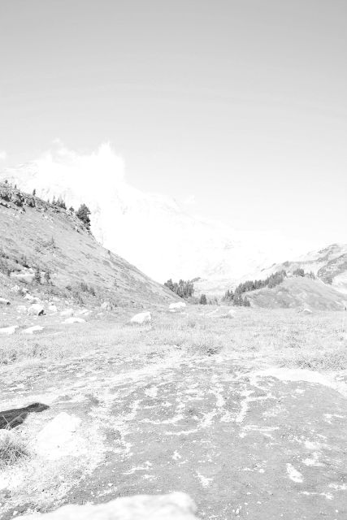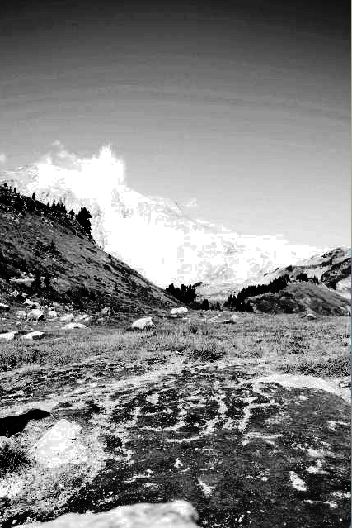

Discussion

The equalizer was able to provide a wider range of contrast making for a better image, however

due to the Low pixel density some areas of color are a bit noisy and the white of the sky remained

fairly bright due to many pixels at max brightness acting as an outlier and affecting the result. With

some pre-processing for outliers the image might come out even better.

Dark Contrast

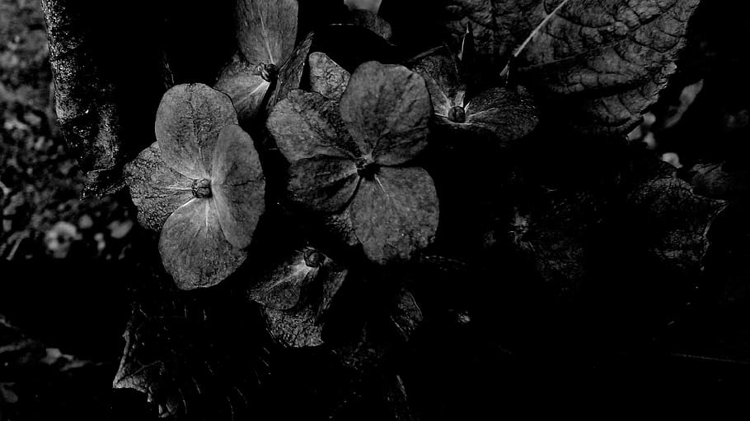

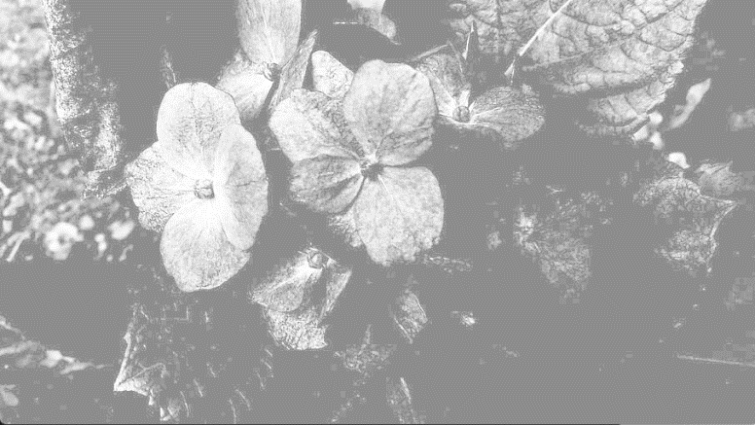

Discussion

The dark contrast image had the least desirable effect but after looking at the plot the

equalizer tried its best with such few pixel intensities for distribution. The CDF has a very steep

gradient early on causing the image brightness to look like it has been affected by an offset value

rather than balancing the contrast.

Conclusion

The algorithm was tricky to implement but also very powerful for image contrast leveling. I appreciate

the the probabilistic approach was used to determine the new intensity values.